Day7 SIGNAL Handling 24/7/24

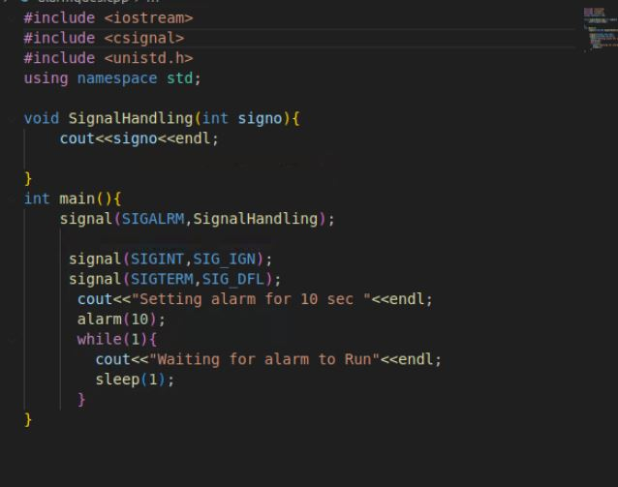

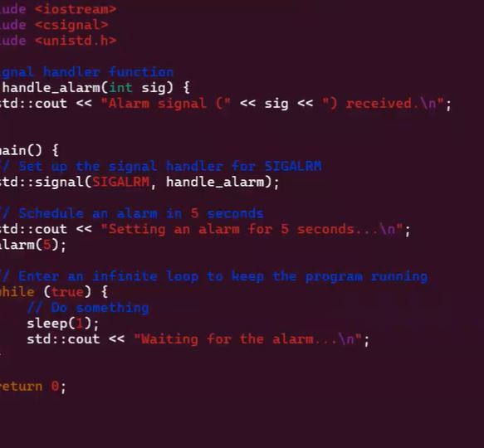

ALARM

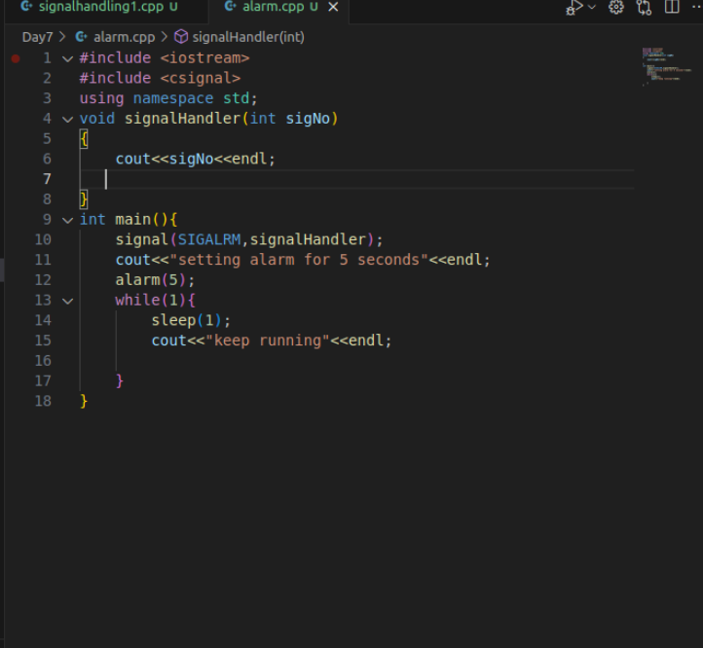

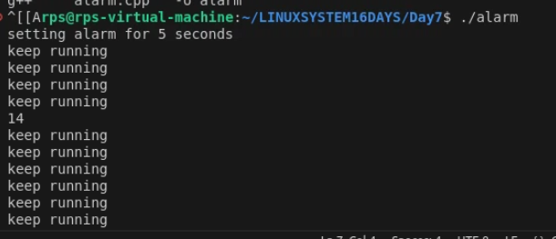

Develop a C++ application that demonstrates effective signal handling using SIGALRM, SIGDEFAULT, and SIG_IGN. The program should:

Set up a timer using alarm() to generate a SIGALRM signal after a specified interval.

Define a signal handler function to process the SIGALRM signal and perform specific actions, such as printing a message, updating a counter, or triggering an event.

Implement logic to handle other signals (e.g., SIGINT, SIGTERM) using SIGDEFAULT or SIG_IGN as appropriate.

Explore the behavior of the application under different signal combinations and handling strategies.

Additional Considerations:

Consider the impact of signal handling on program execution and potential race conditions.

Investigate the use of sigaction for more advanced signal handling capabilities.

Explore the application of signal handling in real-world scenarios, such as timeouts, asynchronous events, and error handling.

**SOCKET PROGRAMMING**

